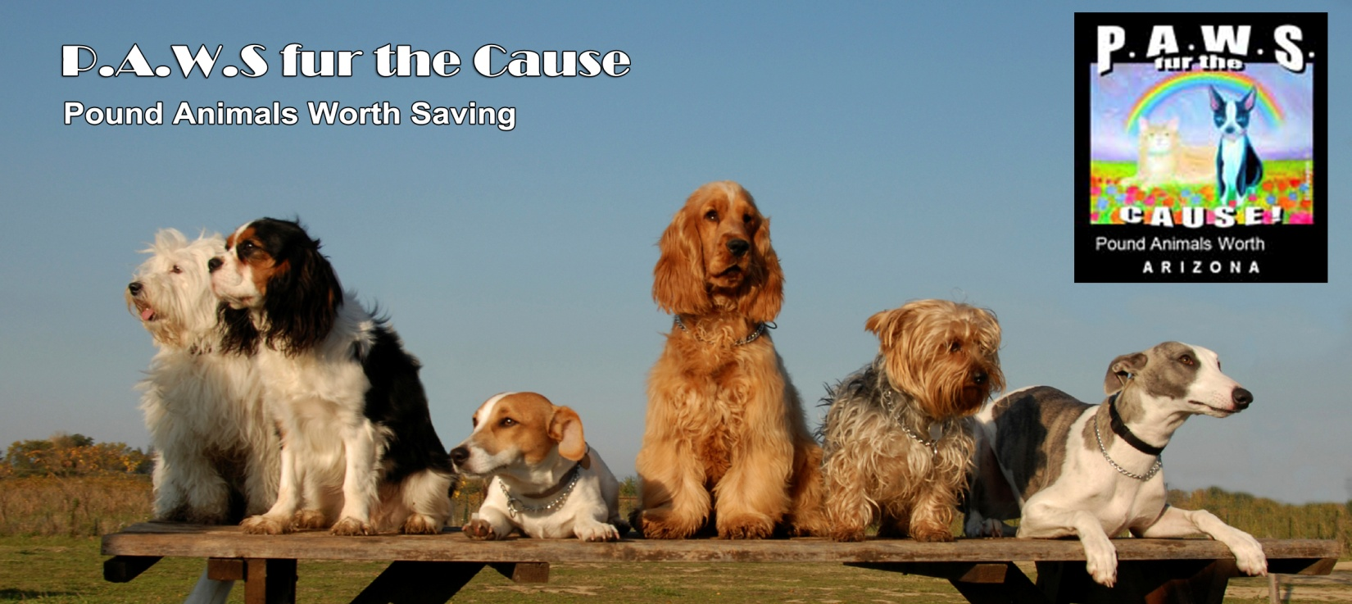
CAT ADOPTION AGREEMENT
FILL OUT THIS FORM AND RETURN TO US AS AN EMAIL ATTACHMENT, OR PRINT AND SEND VIA U.S. MAIL.
Email forms to pawsfosters1@gmail.com. Our mailing address is
P.A.W.S. Fur the Cause
Attn: Karen Mikus
2204 South Catarina
Mesa, Arizona 85202
________________________________________________________
First Name:
Last Name:
Street Address:
City/State/Zip:
Cell Phone Number:
Home Phone Number:
Email Address:
Personal Reference (Name and Phone) :
Vet Name / Phone:
Pet Name:
Pet Sex: M / F
Color(s):
A#:
License #:
Addendums Incorporated: None / Large Breed / Pre Alter Agreement / Foster to Adopt
Adopion Fee (Cash or Credit Card – No Checks) :
Amount Paid (Non Refundable) :

I hereby acknowledge that I am over the age of 18, I have adopted this pet for myself, and I will: (Please check each item)
Give this animal proper and humane care to include appropriate food, fresh water, shelter, exercise, training, attention, and any and all other necessities.
Provide this animal with proper veterinary care at my own expense, both on a regular basis and if my pet becomes ill or injured. P.A.W.S. will not reimburse any medical expenses incurred after signing this agreement.
Keep the animal as a pet and companion, and never let it be used for fighting, experimentation, or for any other unethical purpose.
Comply with all town or city, state and federal laws including leash laws. Dogs are to be properly licensed with the tag attached to the collar on the dog at all times. I will renew the license every year.
Contact P.A.W.S. immediately if I am unable or unwilling to keep this animal. I understand no refunds will be given.
Not use this animal solely as a mouser, guard dog or hunting dog.
I fully understand P.A.W.S. cannot and does not make any representations or warranties, either expressed or implied, concerning the temperament, health, habits or background of this pet and that future reactions to me, my family and other persons are completely unpredictable because animals, like people, have their own personalities. Therefore, and in consideration of receiving this pet, I release P.A.W.S. from all claims of injury or damage which this pet may cause me or my property. I further agree to indemnify and hold harmless P.A.W.S. from and against all claims of liability for bodily injury or property damage caused by this animal. I understand and agree that there will be no refunds. I understand P.A.W.S. does not guarantee the health of this animal and I agree that I am responsible for any and all expenses associated with the immediate and future medical needs of this animal. I understand and agree that exchanges are considered on a case-by-case basis at the sole discretion of P.A.W.S.

______________________________________________________________________________
Adopter Signature / Date

______________________________________________________________________________
P.A.W.S. Coordinator Signature / Date

